

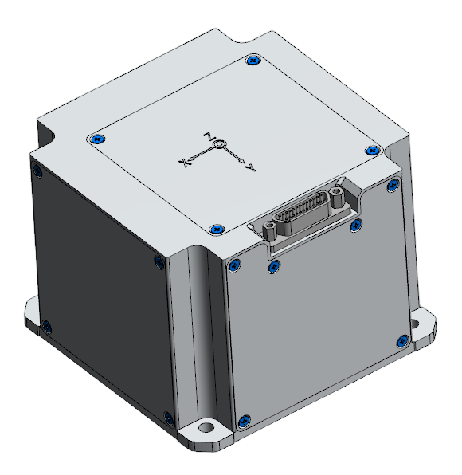

AgileLight -800A Series

Satellite Fiber Optic Gyroscope
Technical Manual
V1.0






Introduction
AgileLight - 800A fiber optic gyroscope is designed specifically for space applications. It not only possesses core characteristics suitable for space environments, such as radiation resistance, low power consumption, long lifespan, vacuum environment tolerance, and rapid start-up response, but its key technical indicators, such as zero-bias stability, far surpass those of MEMS-type gyroscopes. With these advantages, this gyroscope can fully meet the attitude control requirements of various space missions, including communication, remote sensing, observation, and navigation, as well as at different orbital altitudes, effectively improving the platform's attitude control reliability.
This product adopts a mature satellite gyroscope design and has passed tests for ground vibration, shock, thermal vacuum, thermal cycling, total dose, and electromagnetic compatibility.

Applications  - Commercial Spaceflight  - Motion posture control  - Damping of high-speed train swaying  - Antenna/Radar/Optical Platform Stabilization  - Monitoring of building structural deformation  - Inertial search for north | - Automated Cargo Handling Vehicle  - Robot balancing  - Guidance and navigation  - Locking on the aiming system  - oil drilling  - Small inertial navigation system

Performance indicators
Fiber optic gyroscope specifications* | Measuring range |  | ±100°/s
Fiber optic gyroscope specifications* | Isothermal zero-bias stability (100 s, 1σ) |  | ≤0.02°/h
Fiber optic gyroscope specifications* | Zero bias across the entire temperature range (-20℃ to +50℃) |  | ≤±0.3°/h
Fiber optic gyroscope specifications* | Zero-biased repeatability |  | ≤0.04°/h (1σ)
Fiber optic gyroscope specifications* | Scale factor Nonlinearity |  | ≤200ppm
Fiber optic gyroscope specifications* | Scale factor repeatability |  | ≤200ppm
Fiber optic gyroscope specifications* | Angular velocity measurement error |  | Absolute error ≤5×10-4 °/s  (Input ≤0.6°/s)
Fiber optic gyroscope specifications* | Angular velocity measurement error |  | Relative error ≤ 5×10-4 °/s  (0.6°/s ≤ Input ≤ 300°/s)
Fiber optic gyroscope specifications* | Random walk coefficient |  | ≤0.0003°/h ^{1/2}
physical indicators | volume |  | 90mm×90mm×66.5mm
physical indicators | weight |  | 450g±20g
physical indicators | Power consumption |  | ≤4.5w
physical indicators | Start-up instantaneous power |  | ≤12.5w (duration ≤10ms)
physical indicators | Operating temperature |  | -20℃~+50℃
physical indicators | Storage temperature |  | -40℃～+60℃
physical indicators | Operating relative humidity range |  | ≤70%
physical indicators | Storage relative humidity range |  | ≤70%
physical indicators | Communication interface |  | RS422 interface (dual-channel)
physical indicators | Power supply voltage |  | +5.2V±0.3V
Other technical indicators | Startup and signal stabilization time |  | ≤1min
Other technical indicators | Three-axis assembly angle correction data accuracy |  | ≤2′
Other technical indicators | Remnant magnetic moment |  | ≤0.5Am ²
 | Insulation resistance |  | > 10 MΩ

Fiber Optic Gyroscope Specifications: Within the operating temperature range, temperature compensation can be applied—using the unit's internal temperature data and the correction formula derived from calibration tests—if necessary, to ensure the aforementioned performance specifications are met.

Interface definition

Mechanical interface :
- Structural envelope dimensions: (90±0.2) × (90±0.2) × (66.5±0.2) mm;
- Number and size of mounting holes: 4×Φ(4.5±0.1) mm;
- Mounting hole spacing: (75±0.1) mm×(75±0.1) mm;
- Mounting surface flatness: ≤0.1 mm/(100 mm×100 mm);
- Mounting surface roughness: ≤3.2μm;
- Mounting ear thickness: (3.5±0.1) mm;
- Product weight: 0.45 kg ± 0.02 kg;
- Mounting surface contact area: ≥7000mm2.

Power supply interface:
Input and output signals are transmitted through a J30JA-25ZKP type socket. The socket definition is shown in Table 1.
- Power supply voltage: +5.2V±0.3V;
- Ripple voltage: ≤150mV (PP);
- Ripple frequency: ≤10MHz;
- Surge current: ≤2.5A/10ms;
- Steady-state power consumption (full temperature range): ≤5W;
Start-up transient power consumption: ≤12.5W.

Node number | Signal function description | Voltage V | Current A | Polarity | Notes (Shielding/Twisted Pair)
1,14 | +5V power supply | Supply voltage +5 | <2 | + | The main line and return line are twisted together.
3,16 | +5V power return line | 0 | <2 | - | The main line and return line are twisted together.
5,18 | The instruction receives a negative (RX-) signal. | RS422 standard | <0.1 | - | 5, 6 twisted pairs  18, 19 twisted pair
6,19 | Command received positive (RX+) | RS422 standard | <0.1 | + | 5, 6 twisted pairs  18, 19 twisted pair
7,20 | Negative data transmission (TX-) | RS422 standard | <0.1 | - | 7, 8 twisted pairs  20, 21 twisted pair
8,21 | Data transmission in progress (TX+) | RS422 standard | <0.1 | + | 7, 8 twisted pairs  20, 21 twisted pair
9,22 | Payload transmission positive (TX+) | RS422 standard | <0.1 | + | 9, 10 twisted pair  22, 23 twisted pair
10,23 | Payload transmission negative (TX-) | RS422 standard | <0.1 | - | 9, 10 twisted pair  22, 23 twisted pair
12,24 | signal ground | / | / | /
13,25 | chassis ground | / | / | /
2,4,11,15,17 | null | / | / | /

Product Dimensions
Product dimensions: 90×90×48.5 (mm)
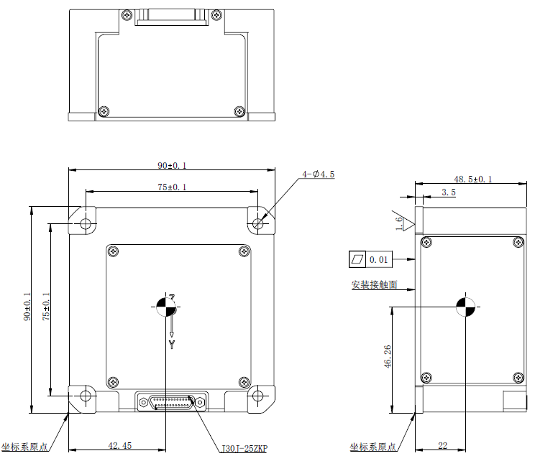


Statement
In the event of a functional failure, please do not attempt to open the housing yourself. The product must be returned to the company for repair. Please note that any damage resulting from misuse or improper repair attempts is excluded from the company's warranty coverage.。

AgileLight -800A Series

Satellite Fiber Optic Gyroscope

Wuxi Bewis Sensing Technology LLC

Address: Building 30, No. 58 Xiuxi Road, Binhu District, Wuxi City, Jiangsu Province, China

Tel：+86 18921292620
Email: sales@bwsensing.com Web: www.bwsensing.com

