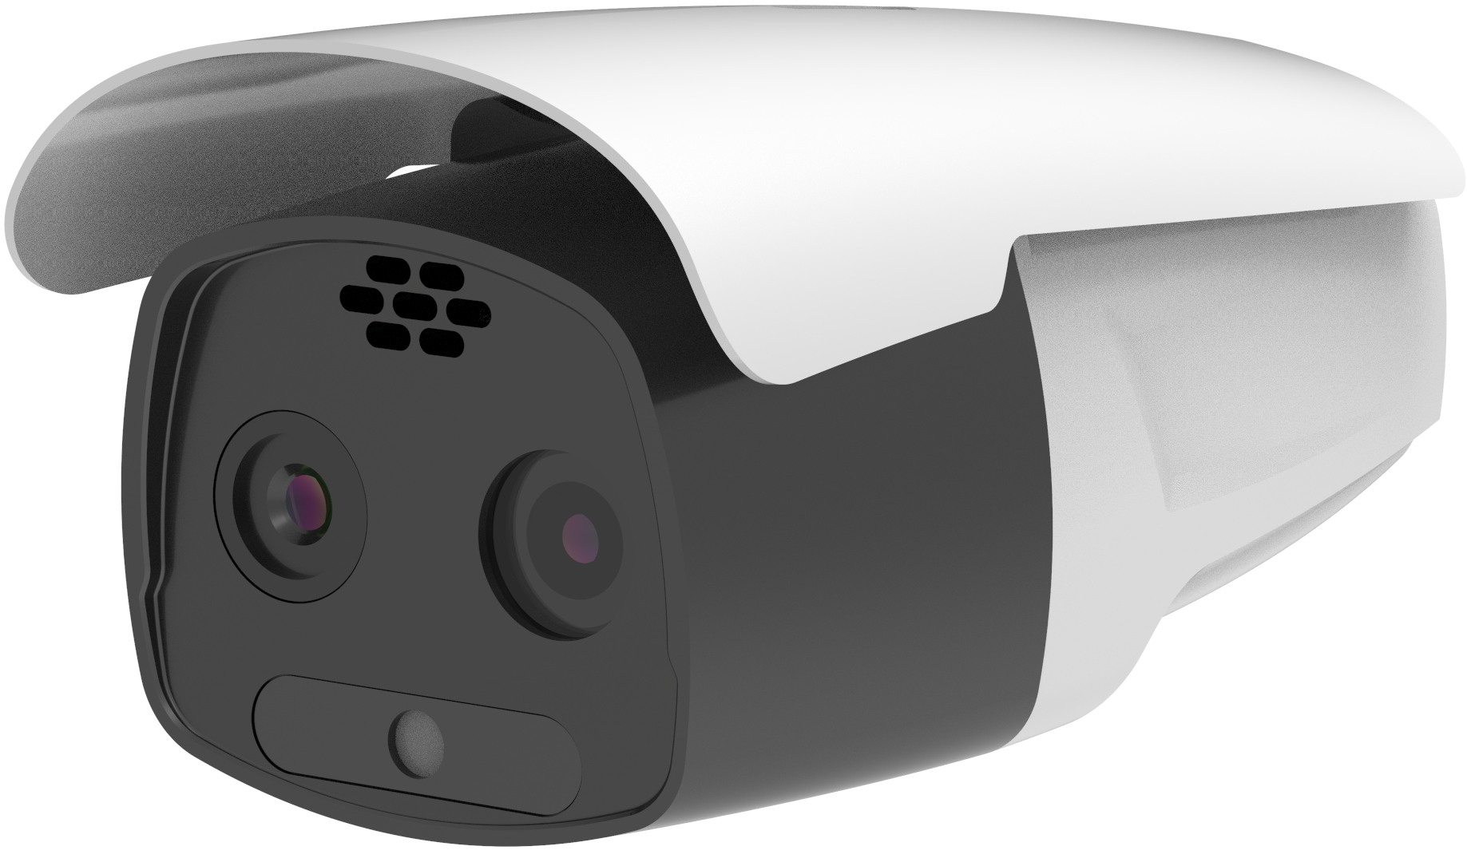

V1.0
Technical Manual

BW-DC13P series
Thermal Imaging Dual Spectrum Camera

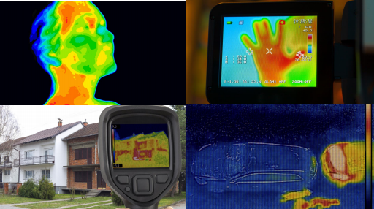
Introduction
Feature
BW-DC series is a self-developed intelligent gain control algorithm, detail hybrid enhancement algorithm and 3D noise reduction algorithm, 10 kinds of pseudo colors, capable of fire point detection, high temperature detection, and detection of regional intrusion, crossing the boundary, and entering/leaving the area. It supports 1 line temperature measurement, 9 frame temperature measurement, 10 point temperature measurement, 2 irregular areas, 2 circular area temperature measurement, full screen highest temperature, lowest temperature positioning, etc. It supports 2 alarm inputs and 2 alarm outputs. It is used in industrial places such as the power industry, chemical disposal centers, combustible warehouses, petrochemical plants, coal mines, etc., where real-time temperature monitoring of key locations is required to prevent dangerous events.
● Excellent image quality
● Intelligent detection
● Accurate temperature measurement
● Abnormal alarm
● Development interface: SDK development kit is provided
● Access standard: general version

Characteristic

Performance Indicators

Product model | BW-DC13P
Thermal Imaging
Detector Type | Vanadium Oxide Uncooled Focal Plane Detector
Image Resolution | 384*288
Element Size | 17μm
Detector NETD | ≦50mK@25℃
Response Band | 8 ~14μm
Package Type | Ceramic Package
Visible light
Sensor | 1/2.8”CMOS
Graphic Resolution | 2592× 1536
Minimum Illumination | 0.002Lux/F1.5(Colour) , 0.0002Lux/F1.5(B/W)
Infrared fill light | Infrared fill light 30 metres
Digital zoom | Support
Automatic Gain Control | ICR Infrared Filter
Image handling
Digital Video | H264
Master Streaming Image | Visible light： 25fps(2592× 1536,1920× 1080,1280×720)
Start-up time | 10s
Image Processing | Non-uniformity correction, intelligent gain control, digital detail mixing enhancement, 3D noise reduction
Colour palette | Support 10 colour palettes such as Black Hot, White Hot, Iron Red, Rainbow, etc./Customizable
Image Mirroring | Left, right, up, down, centre
Function
Abnormal temperature alarm | Support temperature abnormality alarm
Temperature measurement function | Full-screen maximum and minimum temperature positioning
Temperature measurement function | Support 1 line, 9 frames, 10 points, 2 irregular areas, 2 elliptical areas temperature measurement
Temperature measurement function | Temperature range: -20℃~150℃ (extendable to 550℃)@-10~50℃.
Temperature measurement function | Temperature measurement accuracy: ±2℃ or ±2% (take the greater value) no black body
Temperature measurement function | Support reflective temperature, atmospheric temperature setting, target distance correction, support emissivity correction
Alarm | IP conflict, linkage alarm function
Internet
Ethernet Types | 100Mbps
Network Protocols | IPV4, HTTP, FTP, RTSP, RTCP, RTP, TCP, UDP
Concurrent Access | 20 way
Security Mode | Authorised users and passwords
Access Standard | Private SDK, ONVIF, GB/T28181
Data interface
Compressed Data | H264 video, standard JPEG images
System Integration
Communication Interfaces | RJ45, Network Transmission
Communication Interfaces | One RS485
PTZ Control | Pelco-D protocol, RS-485 interface
Alarm Input/Output | 2 in/2 out
Power supply
Power Supply Range | DC12V
Typical Power Consumption | 2.2W
Physical characteristics
Product Size | 96mm*108mm*232mm
Weight (without accessories) | 845.5g(without stand)
Waterproof rating | IP66
Environmental adaptability
Working Temperature/°C | -30℃～+60℃
Storage Temperature/°C | -45℃～+75℃
Humidity/RH | ≤95%

Wuxi Bewis Sensing Technology LLC
Add： Building 30, NO. 58, Xi uxi Road, Binh u District,
Wuxi City, Jiangsu Province, China
Tel： +89 18921292620
Mail ：sales@bwsensing.com
Web：www.bwsensing.com

BW-DC13P series
Thermal Imaging Dual Spectrum Camera

