
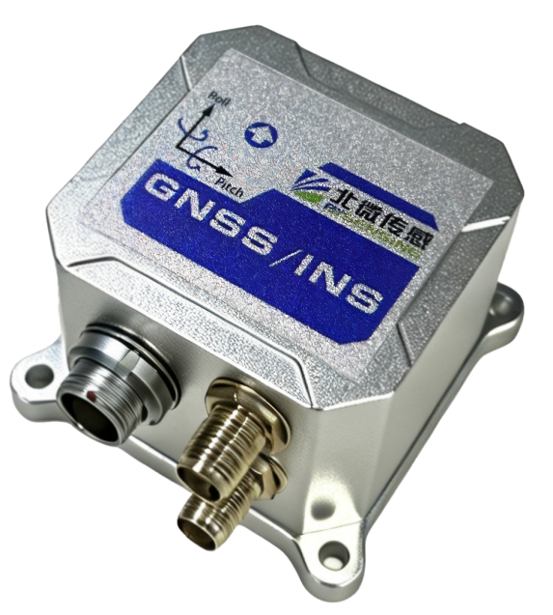
Eleven-axis High-range Integrated Navigation System
BW-GI420
Technical Manual
V1.0

Introduction
GI420 is a cost-effective, long-range 11-axis integrated navigation product designed to provide customers with stable and reliable inertial measurement and navigation information. It undergoes rigorous calibration and compensation at the factory to ensure stable and reliable IMU data. In integrated navigation calculations, a high-performance fusion algorithm is used to deeply integrate IMU and GNSS data, resulting in high reliability and robustness.
GI420 supports IMU raw data output (three-axis gyroscope, three-axis accelerometer, three-axis magnetometer, barometric altimeter), GNSS position and velocity raw data output , and also supports integrated navigation information output , offering diverse options to meet customer needs. Additionally, it provides precise satellite time synchronization, providing a time reference.
It can meet the needs of customers in multiple scenarios, with applications including vehicles, ships, airplanes, gimbals, pods, etc. The GI420 integrated navigation algorithm can be customized and adapted to different dynamic models according to customer scenario requirements to achieve high-precision measurement and navigation positioning.

Features
High-precision integrated navigation interface types are abundant
High performance, cost-effective Supports full-system, full-frequency RTK
High-frequency, stable output Rigorous calibration and compensation
Motion model adaptation supported Supports AHRS
Supports external odometer Supports customization
Supports raw 11-axis IMU data output
Wide range options available, suitable for high dynamics

Technical

IMUPerformance Parameters
gyroscope | range | ±2000°/s | Maximum measurement ±2600°/s
gyroscope | range | ±300°/s
gyroscope | Zero bias stability | 6°/h | National military standard 10-second smoothing
gyroscope | Zero bias stability | 3°/h | National military standard 10-second smoothing
gyroscope | Zero bias instability | 2°/h | Allan variance
gyroscope | Zero bias instability | 0.5°/h | Allan variance
gyroscope | Zero-biased repeatability | <6°/h
gyroscope | Zero-biased repeatability | <3°/h
gyroscope | Angle Random Walk | 0.26°/√h
gyroscope | Angle Random Walk | 0.03°/√h
gyroscope | noise | 0.02°/s
gyroscope | noise | 0.004°/s
accelerometer | range | ±16 g | Maximum measurement ±26g
accelerometer | range | ±8 g
accelerometer | Zero bias stability | 0.05 mg | National military standard 10-second smoothing
accelerometer | Zero bias stability | 0.08mg | National military standard 10-second smoothing
accelerometer | Zero bias instability | 0.015 mg | Allan variance
accelerometer | Zero bias instability | 0.022mg | Allan variance
accelerometer | Zero-biased repeatability | <0.3 mg
accelerometer | Zero-biased repeatability | <0.35 mg
accelerometer | Speed Random Walk | 30 ( mm/s) /√h
accelerometer | Speed Random Walk | 32 ( mm/s) /√h
accelerometer | noise | 0.008 m/s^2
accelerometer | noise | 0.00 9m/s^2
magnetometer | Dynamic range (scale) | ±2Gs
magnetometer | Sensitivity | 15000 LSB/G
magnetometer | Field resolution | 2mGauss
barometric altimeter | Pressure range | 260 hPa~1260 hPa
barometric altimeter | resolution | 4096 LSB/hPa
barometric altimeter | accuracy | ±0.1 hPa | 25℃, 800-1100hPa

Navigation performance parameters
GNSS | satellite signal | BDS  GPS  Galileo  GLONASS  QZSS | B1I/B2I/B3I  L1C/A/L2P(Y)/L2C/L5  E1/E5a/E5b  G1/G2  L1/L2/L5
GNSS | Timing Accuracy (RMS)  Velocity Accuracy (RMS)  Speed Limit (RMS) | 20ns  0.03m/s  300m/s
GI420 Integrated Navigation | Roll Angle Range | ±180°
GI420 Integrated Navigation | Pitch Angle Range | ±90°
GI420 Integrated Navigation | Compass Range | 0~360°
GI420 Integrated Navigation | Horizontal attitude accuracy (RMS) | 0.1°
GI420 Integrated Navigation | Course Accuracy (RMS) | 0.1°
GI420 Integrated Navigation | Course accuracy  (GNSS lock loss) | <0.15° | Course drift (1 min)
GI420 Integrated Navigation | RMS speed accuracy | 0.03m/s
GI420 Integrated Navigation | Position accuracy  (RMS, with accuracy limits determined by GNSS) | 1.5m  2.5m  0.4m  0.8m  0.8cm+1ppm  1.5cm+1ppm | SPP Horizontal Plane  SPP Vertical  DGPS Plane  DGPS Altitude  RTK Plane  RTK Altitude
GI420 Integrated Navigation | Ingress Protection Rating | IP67
GI420 Integrated Navigation | Dimensions | 46*45*32mm
GI420 Integrated Navigation | Operating Voltage | DC 9~36V
GI420 Integrated Navigation | Operating Temperature | -40~+85℃
GI420 Integrated Navigation | Storage Temperature | -55~+95℃

Interfaces
Interface Type
GI420 device side | External terminals | /
12-pin metal plug (Female) | 12-pin metal socket (Male) | Power & Communication Interfaces
SMA (Female) | SMA male (Male) | GNSS main antenna interface
SMA (Female) | SMA male (Male) | GNSS from antenna interface
Serial Port Settings
Baud rate | 921600 / 460800 / 230400 / 115200 / 19200 / 9600 / 2400
Data bits | 8
Default configuration | 115200 8 1 No verification
Serial port optional | RS4 22 (RS4 85 ) / RS 232
Additional Interfaces
1-channel CAN FD interface

Packing List
Type | Name | Model | Quantity | Remark
Standard | 11-axis integrated navigation | GI420 | 1 | Net weight 65 g
Standard | Power & communication interface | 12-pin metal plug (male + 1m cable) | 1 | Net weight 63 g
Optional | GNSS antenna ① | Ceramic antenna 231 + SMA straight male feed cable 5m (integrated) | 2
Optional | GNSS antenna ② | C03 mushroom-shaped antenna + 5m SMA direct- to-TNC feed cable | 2
Optional | GNSS antenna ③ | Quad-arm spiral antenna + 5m SMA direct- to-SMA bus feeder | 2
Optional | 4G DTU module | MD-649R | 1
Optional | Serial port adapter module | DB9 (female) adapter board --- RS232/ RS422 | 1
Optional | RS232 serial to USB | RS232 to USB --- DB9 (Male) | 1
Optional | RS422 serial to USB | RS422 to USB --- DB9 (Male) | 1
Note:
GNSS antenna ①: Four-satellite full-band, dimensions 60*60*22.8mm, with magnet and 3M adhesive.
GNSS Antenna ②: Full-band, φ154mm, with studs and magnetic base.
GNSS Antenna ③: Four-satellite, multi-band, φ28*58.5mm.
Antenna ① is a ceramic-encapsulated antenna with 3M adhesive and a magnetic base. Its performance is slightly inferior to the quad-helix antenna ③ and the mushroom-shaped antenna ②. The mushroom-shaped antenna has the best performance but is the largest and heaviest. For airborne applications, the quad-helix antenna is recommended; for vehicle and shipborne applications, the mushroom-shaped antenna is recommended.
Pin Definition
Serial Number | definition | describe | 12-pin aviation connector pins
1 | A GND | negative terminal of power supply | PIN 1
2 | POWER_IN | DC_9-36V | Pin 2
3 | CANH | CAN signal pin | Pin 3
4 | CANL | CAN signal pin | Pin 4
5 | 232RXD | 232 communication pin | Pin 5
6 | 232TXD | 232 Communication pin | Pin 6
7 | DGND | Digital | Pin 7
8 | PPS_3.3V | Clock synchronization pulse (3.3V) | Pin 8
9 | 485_A/422_T+ | 485/422 communication pins | Pin 9
10 | 485_B/422_T- | 485/422 communication pin | Pin 10
11 | 422_R+ | 422 communication pin | Pin 11
12 | 422_R- | 422 communication pin | Pin 12

Slave antenna antenna
Main antenna
Hardware Connection Diagram

Installation
Dimensions: L46 × W45 × H32 (mm)
Dimensions

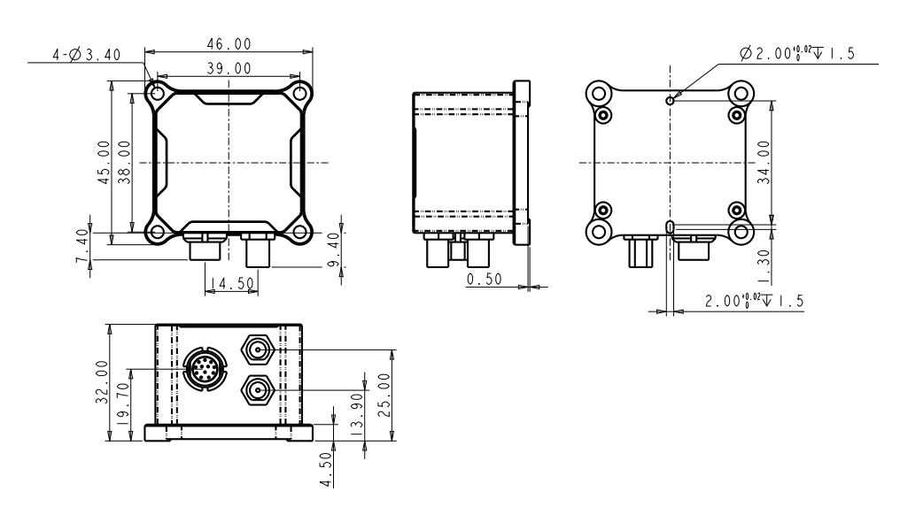
GNSS Antenna Specifications
The GNSS antenna used with the GI420 must be an active antenna. The GI420 requires a 5V DC antenna feed and supports a maximum current of 200mA. Recommended or required parameters are as follows.
- Frequency points to be supported：
GNSS | frequency | GNSS | frequency
BDS | B1I/B2I/B3I | Galileo | E1/E5a/E5b
GPS | L1/L2/L5 | QZSS | L1/L2/L5
GLONASS | G1/G2 | - | L-band
- Recommended gain: 40dB;
- Recommended noise figure: NF < 1.5;
- Power supply: 2.8~5V;
- Phase center error: ±2mm.
RF Coaxial Cable Specifications
The main antenna RF coaxial cable must be impedance matched to both the antenna and receiver, with a characteristic impedance of 50Ω and a recommended line attenuation of < 10dB. One end of the RF coaxial cable connector is adapted to the GNSS antenna, and the other end is an SMA male connector adapted to the GI420 main antenna interface .
The antenna is the same as above, and the other end is an SMA male adapter for the GI420 antenna interface.
Temperature and IP Rating
The temperature requirements for GI420 are as follows:
1.Operating temperature : -40℃~+85℃
2.Storage temperature : -55℃ to +95℃
3.Protection rating: IP67
Power Supply Specifications
The GI420 has the following power supply requirements:
1.Voltage range 9~36V DC
2.At least 10W stable output power
GNSS Antenna Installation
The following precautions should be taken when installing a GNSS antenna:
1.The area above the GNSS antenna is open and unobstructed.
2.The GNSS antenna is rigidly connected to the carrier, ensuring that the antenna will not sway when the carrier moves.
3.For dual antennas, it is recommended that the antennas be as far apart as possible.
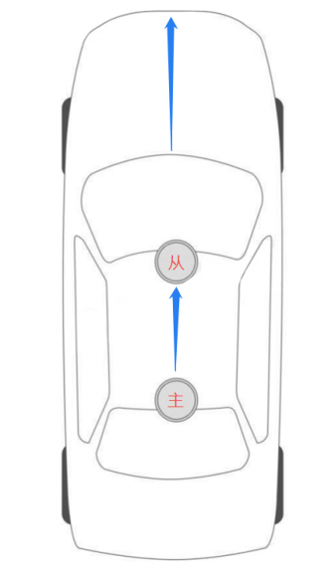
To simplify configuration, in GNSS dual-antenna mode, it is recommended that the baselines of both antennas be horizontal to the vehicle's forward direction, meaning the direction the main antenna points towards the secondary antenna should be consistent with the direction the rear of the vehicle points towards the front (main antenna at the rear, secondary antenna at the front) , as shown in the diagram below:
GI420 Installation
To improve accuracy, the IMU should be positioned as close as possible to the GNSS main antenna in the horizontal direction during installation . A rigid connection between the GI420 and the carrier must be ensured, guaranteeing that their relative positions on the carrier remain constant. Furthermore, the GI420 must be securely and reliably installed, preventing movement or shaking during carrier movement.
Installation Requirements: The GI420 should be horizontally aligned with the carrier (i.e., the Z-axis should be perpendicular to the carrier's upward direction). The Y-axis of the GI420 should point in the carrier's forward direction. It is essential to ensure that the Y-axis of the GI420, the direction from the main antenna to the secondary antenna, and the direction of the carrier's forward direction all point in the same direction (as shown in the diagram below) ：
Communication Connection
GI420 can communicate with external communication devices via serial port. Currently, commands and RTK data can only be sent through the RS232 port.
Serial Interface
GI420 integrated navigation system provides two serial ports, as shown in the table below :
Serial number | RS-232 | RS-485 | RS-422
COM1 | support | Not supported | Not supported
COM2 | Not supported | support | support
Power Connection
The 12-core cable has pin 2 POWER_IN connected to the positive power supply and pin 1 AGND connected to the negative power supply.
Check GI420 Status
After installing the GI420, connect the power and send the command UNLOG. Note that when using a serial port assistant to send commands, you need to check "Send Newline" to confirm whether the GI420 is running normally. If so, the GI420 will reply with the following content:
$Command UNLOG response: OK。
Operation
Before use, ensure that the GI420 has been installed as described in the previous section and is powered on.。
Serial Communication
The GI420 can communicate with devices such as computers via serial port. Before establishing communication, both the GI420 and the computer need to have their serial port parameters properly configured. The default serial port configuration for the GI420 is as follows:
1.115200bps
2.No parity bit
3.8-bit data bits
4.1 stop bit
5.No parity bit
Only COM1 supports port configuration using the CONFIG command.
Here's an example of modifying the COM1 serial port configuration：
Command Header | Serial port devices | Serial port parameters | Parameter Description
CONFIG | COM1  COM2 | baud rate | Set the serial port baud rate

instruction | describe
config com1 115200 | Set the baud rate of COM1 to 115200.  COM1 supports baud rates of 2400, 9600, 19200, 115200, 230400, and 460800. COM2 supports the following baud rates: 2400, 9600, 19200, 115200, 230400, 460800, and 921600.
The command format is:
CONFIG [Serial Port Device Number] [Serial Port Attributes]
GNGGA GNSS
This command is used to set the output of the multi-system joint positioning results for the current serial port or a specified serial port. The output information includes the GNSS receiver's time and positioning-related data. The statement begins with GNGGA. Depending on the satellite system involved in the positioning, it may be GPGGA, BDGGA, GLGGA, or GAGGA. When only the GPS satellite system is involved in the positioning calculation, it is output in GPGGA format; when only the BDS satellite system is involved, it is output in BDGGA format; when only the GLONASS satellite system is involved, it is output in GLGGA format; when only the Galileo satellite system is involved, it is output in GLGGA format.
Output in GNGGA format. If two or more satellite systems are involved in the positioning calculation, the output will be in GNGGA format.
Simplified ASCII format:
GNGGA 1 Currently outputs 1Hz GNGGA information via serial port.
GNGGA COM2 1 outputs 1Hz GNGGA information at COM2.
Message output:
$GNGGA,025754.00,4004.74102107,N,11614.19532779,E,1,18,0.7,63.3224,M,-
9.7848,M,00,0000*58
GNGGA data structure :：
ID | Fields | Data Description | symbol | Example
1 | $GNGGA | Log header |  | $GNGGA
2 | UTC | The corresponding UTC time for the location  hh/mm/ss.ss | hhmmss.ss | 17 3568 .00
3 | lat | Latitude (DDmm.mm ) | IIII.II | 3251. 2654​
4 | Lat dir | Latitude direction (N = North, S = South) | a | N
5 | lon | Longitude (DDDmm.mm ) | yyyyy.yy | 12033.3 59 2​
6 | lon dir | Longitude direction (E = East, W = West) | a | E
7 | qual | GPS quality indicator  0 = Location unavailable or invalid  1 = Single point positioning  2 = Pseudorange differential or SBAS positioning  4 = RTK fixed solution  5 = RTK floating-point solution  6 = Inertial Navigation Positioning  7 = User-defined location ( Fixed)  Position ) | x | 1
8 | # sats | Number of satellites in use. This may differ from the number seen.  Inconsistent | xx | 10
9 | hdop | Horizontal precision factor | xx | 1.0
10 | alt | The antenna's altitude is below the geoid.  It is a negative value. | xx | 10 21 .4 5
11 | a-units | Antenna height unit (M = m ) | M | M
12 | undulation | Geoid Disparity – Geoid and  the WGS84 ellipsoids. Large  A positive value indicates the geoid is above the ellipsoid; otherwise...  Then, the value is negative. | xx | -1 7.1 83​
13 | u-units | Geoid difference unit (M = m ) | M | M
14 | age | Differential data age, in seconds | xx | 00 when there is no difference data )
15 | stn ID | Differential base station ID , 0000-4096 | xxxx | 00 when there is no difference data )
16 | *xx | Checksum | *hh | *3F
17 | [CR][LF] | Statement terminator |  | [CR][LF]
IMU raw data information
This statement contains IMU status indications and measurements from the accelerometer and gyroscope relative to the IMU housing coordinate system.
Command format: RAWIMUA COM1 1
RAWIMU data format:
RAWIMU data format:：
ID | Fields | Data Description
1 | $RAWIMUA | Log header
2 | Week | GNSS Week
3 | Seconds into Week | Zhou Miao
4 | X Accel Output | Acceleration along X Axis variation
5 | Y Accel Output | Acceleration varies along the Y-axis
6 | Z Accel Output | Acceleration varies along the Z-axis
7 | X Gyro Output | Angular change of the right-hand screw along the X-axis
8 | Y Gyro Output | Angular change of the right-hand screw along the Y- axis
9 | Z Gyro Output | Along Z angular change of the right-hand screw of the shaft
10 | X Mag Output | Magnetometer along X Axis variation
11 | Y Mag Output | Magnetometer along Y Axis variation
12 | Z Mag Output | Magnetometer along Z Axis variation
13 | Barometer Output | barometer changes
14 | *xx | Checksum
15 | [CR][LF] | Statement terminator
INSPVA Integrated Navigation Position, Velocity, and Attitude Information
To set the output of the combined navigation positioning result, ASCII statements must begin with "#INSPVAA".
Recommended input: INSPVAA com2 1
INSPVAA data structure：
ID | Fields | Data Description
1 | $ INSPVA A | Log header
2 | Week | GNSS Week
3 | Seconds | Zhou Miao
4 | Longitude | Longitude (WGS84) [degrees]
5 | Latitude | Latitude (WGS84) [degrees]
6 | Height | Ellipsoid height (WGS84) [m]
7 | North Velocity | Northbound speed ( negative values for southbound ) [m/s]
8 | East Velocity | Eastbound velocity ( negative values for westbound ) [m/s]
9 | Down Velocity | Ground velocity [m/s]
10 | Roll | Roll angle ( right-hand spiral along the Y-axis, counter-clockwise is positive) [ degrees ]
11 | Pitch | Pitch angle ( right-hand screw along the X-axis, counter-clockwise is positive) [ degrees ]
12 | Azimuth | The heading angle is 0° or 360° for true north ( northeast is positive). This is the inertial azimuth angle calculated by the IMU gyroscope through a combined filter.
13 | Ahrs_Roll | The roll angle output by Ahrs ( right-hand spiral along the Y- axis, counter-clockwise is positive) [ degrees ]
14 | Ahrs_Pitch | output by Ahrs ( right-hand screw along the X- axis, counter-clockwise is positive) [ degrees ]
15 | Ahrs_Azimuth | The heading angle output by Ahrs is 0° or 360° for true north ( northeast is positive). This heading angle output is compensated for magnetic declination, therefore 0° or 360° is true north .
16 | Track_Angle | Track angle, 0° or 360° for true north (northeast is positive) [ degrees ]
17 | H_e | Height (in meters)
18 | H_brao | Barometer height [meters]
19 | Fbb_0 | The acceleration [g] of the carrier in the X direction, in units of g, is 9.794362833435068.
20 | Fbb_1 | The acceleration [g] of the carrier in the Y direction, in units of g, is 9.794362833435068.
twenty one | Fbb_2 | The acceleration [g] of the carrier in the Z direction, in units of g, is 9.794362833435068.
twenty two | vel_body_0 | Carrier velocity in the X direction [m/s]
twenty three | vel_body_1 | Carrier velocity in the Y direction [m/s]
twenty four | vel_body_2 | Carrier velocity in the Z direction [m/s]
25 | Gnssvalue | The Gnss valid flag is set to 0 for invalid and 1 for valid.
26 | Sats | number of satellites
27 | PositionStatus | Location status
28 | DirectionStatus | Orientation state
29 | Temperature | Temperature. Degrees Celsius (°C)
30 | PDOP | Position accuracy factor
31 | * xx | Checksum
32 | [CR][LF] | Statement terminator ( ASCII only )
INSPVAB integrated navigation position, velocity, and attitude information
To set the output of the integrated navigation positioning result, the binary statement must begin with "#INSPVAB".
Recommended input: INSPVAB com2 1
INSPVAB data structure：
ID | Fields |  | Data Description | type | byte count | Byte offset
1 | Synchronization segment |  | 0x57 | char | 1 | 0
2 | Frame information |  | 0x00 | char | 1 | 1
3 | Length segment |  | 0xcf | char | 1 | 2
4 | address range |  | 0x00 | char | 1 | 3
5 | command segment |  | 0x03 | char | 1 | 4
6 | Data segment | Week | GNSS Week | Ulong | 4 | 8
6 | Data segment | Seconds | Zhou Miao | Double | 8 | 16
6 | Data segment | Longitude | Longitude (WGS84) [degrees] | Double | 8 | twenty four
6 | Data segment | Latitude | Latitude (WGS84) [degrees] | Double | 8 | 32
6 | Data segment | Height | Ellipsoid height (WGS84) [m] | Double | 8 | 40
6 | Data segment | North Velocity | Northbound speed ( negative values for southbound ) [m/s] | Double | 8 | 48
6 | Data segment | East Velocity | Eastbound velocity ( negative values for westbound ) [m/s] | Double | 8 | 56
6 | Data segment | Down Velocity | Ground velocity [m/s] | Double | 8 | 64
6 | Data segment | Roll | Roll angle ( right-hand helix along the Y- axis, counter-clockwise is positive) [ degrees ] | Double | 8 | 72
6 | Data segment | Pitch | Pitch angle ( right-hand screw along the X- axis, counter-clockwise is positive) [ degrees ] | Double | 8 | 80
6 | Data segment | Azimuth | The heading angle, rotated counterclockwise from north ( right-handed spiral around the Z-axis, with north-northeast as positive), is the inertial azimuth angle calculated by the IMU gyroscope through a combined filter. | Double | 8 | 88
6 | Data segment | Ahrs_Roll | The roll angle output by Ahrs ( right-hand spiral along the Y- axis, counter-clockwise is positive) [ degrees ] | Double | 8 | 96
6 | Data segment | Ahrs_Pitch | output by Ahrs ( right-hand screw along the X- axis, counter-clockwise is positive) [ degrees ] | Double | 8 | 104
6 | Data segment | Ahrs_Azimuth | The heading angle output by Ahrs is 0° or 360° for true north ( northeast is positive). This heading angle output is compensated for magnetic declination, therefore 0° or 360° is true north . | Double | 8 | 112
6 | Data segment | Track_Angle | Track angle, 0° or 360° for true north (northeast is positive) [ degrees ] | Double | 8 | 120
6 | Data segment | H_e | Height (in meters) | Double | 8 | 128
6 | Data segment | H_brao | Barometer height [meters] | Double | 8 | 136
6 | Data segment | Fbb_0 | The acceleration [g] of the carrier in the X direction, in units of g, is 9.794362833435068. | Double | 8 | 144
6 | Data segment | Fbb_1 | The acceleration [g] of the carrier in the Y direction, in units of g, is 9.794362833435068. | Double | 8 | 152
6 | Data segment | Fbb_2 | The acceleration [g] of the carrier in the Z direction, in units of g, is 9.794362833435068. | Double | 8 | 160
6 | Data segment | vel_body_0 | Carrier velocity in the X direction [m/s] | Double | 8 | 168
6 | Data segment | vel_body_1 | Carrier velocity in the Y direction [m/s] | Double | 8 | 176
6 | Data segment | vel_body_2 | Carrier velocity in the Z direction [m/s] | Double | 8 | 184
6 | Data segment | Gnssvalue | The Gnss valid flag is set to 0 for invalid and 1 for valid. | char | 1 | 185
6 | Data segment | Sats | number of satellites | char | 1 | 186
6 | Data segment | PositionStatus | Location status | char | 1 | 187
6 | Data segment | DirectionStatus | Orientation state | char | 1 | 188
6 | Data segment | Temperature | Temperature. Degrees Celsius (°C) | Double | 8 | 196
6 | Data segment | PDOP | Position accuracy factor | Double | 8 | 204
6 | Data segment | Status | INS status | Enum | 1 | 205
7 |  | xxxx | 32-bit CRC | Hex | 4 | 209

Other instructions
Unlog stops serial port output
This command is used to stop the serial port from outputting specific data. The configurable parameter [statement] stops the output of the corresponding data; the configurable parameter [port] stops port output. If no port is specified, the default is the port currently receiving the command; if no message name is specified, all information output will be stopped.
The command format is:
UNLOG [port] [message]
Simplified ASCII syntax
UNLOG stops all output from the current serial port.
The UNLOG GNGGA statement stops the current serial port from outputting GNGGA.
UNLOG COM1 Stops all information output from COM1.
The UNLOG COM2 GNGGA statement stops the GNGGA output from COM2.
The Unlog command parameters are as follows：
Command Header | port number | describe
UNLOG | COM1  COM2 | The name of the message to stop output

Saveconfig saves user configuration.
This command saves the current user configuration.
The command format is:
SAVECONFIG
Simplified ASCII syntax:
SAVECONFIG
Saveconfig command parameters are as follows：
Command Header | Command parameters | describe
SAVECONFIG | —— | Save user configuration

IMU to main antenna mast parameter configuration
Use this command to input the offset between the IMU and the GNSS main antenna phase center, i.e., the inertial navigation system (INS) to main antenna boom parameter. The boom parameter should be measured as accurately as possible, especially in RTK mode; the error should ideally be within 1 cm. Any error in the boom parameter will be directly converted into an error in the INS position. X, Y, and Z represent the vector from the IMU to the main antenna phase center (measured with the IMU center as the origin and the coordinate system as right-front-upper) . To improve accuracy, the IMU should be installed as close as possible to the GNSS main antenna in the horizontal direction.
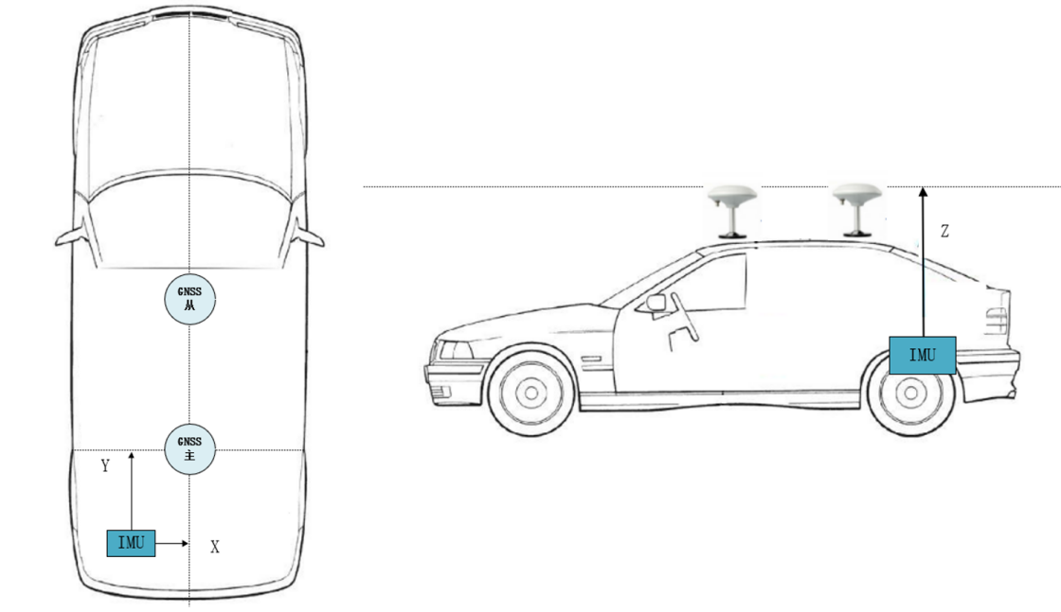
Offset from IMU to antenna phase center
Command format: CONFIG LEVER ARM xyz
Simplified ASCII syntax: CONFIG LEVER ARM 0.05 -1.05 0.03
IMU to main antenna boom parameter configuration
Command Header | parameter | Parameter Description
CONFIG LEVER  ARM | X | X-direction offset, unit: meters, range: -100 to 100 , rounded to two decimal places.
CONFIG LEVER  ARM | Y | Y-direction offset, unit: meters, range: -100 to 100 , rounded to two decimal places.
CONFIG LEVER  ARM | Z | Z-direction offset, unit: meters, range: -100 to 100 , rounded to two decimal places.

Command Set Table
Order | Example | Notes and Explanations
UNLOG COM1 |  | Turn off all outputs of 232.
UNLOG COM2 |  | Turn off all outputs of 485/422
GNGGA COM1 1 |  | The RS-232 outputs GNGGA data at 1 Hz. When using RTK, the RS-232 needs to output GNGGA data to the Qianxun base station.
INSPVAA COM1 XX | INSPVAA COM1 0.05 | XX represents the reciprocal of the output frequency; in the example, it means that the 232 outputs data in INSVPA format at 20 Hz.
INSVAB COM1 XX | INSPVAB COM1 0.05 | XX represents the reciprocal of the output frequency; in the example, it means that the 232 outputs data in INSVAB format at 20Hz.
INSPVAA COM2 XX | INSPVAA COM2 0.05 | XX represents the reciprocal of the output frequency; in the example, it indicates that the 485/422 outputs data in INSPVA format at 20Hz.
INSPVAB COM2 XX | INSPVAB COM2 0.05 | XX represents the reciprocal of the output frequency; in the example, it indicates that the 485/422 outputs INSVAB format data at 20Hz.
CONFIG COM1 XXX | CONFIG COM1 460800 | XXX represents the baud rate. In this example, the baud rate of the RS-232 is set to 460800. RS-232 supports baud rates of 2400, 9600, 19200, 115200, 230400, and 460800.
CONFIG COM2 XXX | CONFIG COM2 460800 | XXX represents the baud rate. In the example, setting the baud rate for 485/422 indicates a baud rate of 460800. Supported baud rates for 232 are 2400, 9600, 19200, 115200, 230400, 460800, and 921600.
CONFIG LEVER ARM XX YY ZZ | CONFIG LEVER ARM 0.35 0.55 1.15 | XX YY ZZ represents the XYZ axis distance between the center of the main antenna and the center of the integrated navigation system, with the right front upper direction as the positive direction. The measurement of the boom arm is referenced in the previous section " IMU to Main Antenna Parameter Configuration ". Unit: meters.
CONFIG HEADING COMP XX | CONFIG HEADING COMP 30 | XX represents the heading angle between the line connecting the master and slave antennas (pointing from the master antenna to the slave antenna) and the longitudinal axis of the carrier (pointing to the carrier's forward direction), in degrees. This item is only required when there is a significant angle between the two; otherwise, it is not necessary. When shown in the diagram below, the angle is set to positive; otherwise, it is negative. The unit is degrees, and the range is [-360°, +360°].  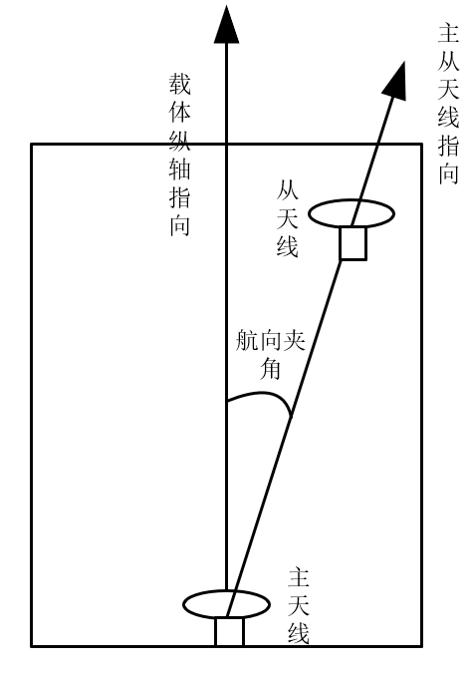
CONFIG LEVER ARM OTHER XX YY ZZ | CONFIG LEVER ARM OTHER 0.15 -0.35 1.05 | Configure the output position anywhere. Using the center of the integrated navigation system as the origin and the upper right-front-right direction as the positive direction, measure the XYZ axis distances from the desired output position to the center of the integrated navigation system. Refer to the previous section " IMU to Main Antenna Parameter Configuration " for the coordinate system of the integrated navigation system. Unit: meters.
CONFIG CARRIER MOD XX | CONFIG CARRIER MOD 1 | Configure the algorithm mode of the integrated navigation system. Different algorithm modes are configured according to different carriers and application scenarios.  0 represents airborne mode,  1 represents vehicle mode,  2 represents shipborne mode,  and 3 represents construction machinery mode (agricultural machinery, excavators, mining trucks, etc.).
CONFIG BW VALUE XX | CONFIG BW VALUE 1 | Configure whether to remove the initial zero bias. 0 means do not remove, 1 means remove, and the default is 1 (removing the initial zero bias will make the integrated navigation perform better when GNSS lock is lost).

Magnetometer calibration
- via COM 1 RS232. Open the serial port and configure it to transmit via HEX and receive via HEX.
- Position the sensor with a pitch angle of 0°, a roll angle of 0°, and a yaw angle pointing due north. Use this direction as the reference direction. If you don't know where due north is, you can use any direction as the reference direction. Keep the sensor stationary and send the start calibration command 77 05 00 E4 01 EA. The sensor will return 77 05 00 E4 01 EA, initiating calibration mode. After calibration mode is initiated, it will automatically send 77 05 00 E5 XX YY , where XX is the calibration count. This value will iterate continuously during motion calibration and converge and begin to increase when stationary.
- Slowly rotate the sensor one revolution around the X-axis.
- Slowly rotate the sensor one revolution around the Y-axis.
- Slowly rotate the sensor one full revolution around the Z-axis to complete the rotation step.
- Place the sensor still and wait for the return command 77 05 00 E5 XX YY, where XX is greater than or equal to 0x0A. The calibration is then considered complete.
- Send the calibration end command 77 05 00 E4 02 EB. Calibration complete.
- To erase magnetometer calibration parameters, send the command. 77 04 00 10 14

Appendix: Binary Protocol Format
Synchronization segment  1 Byte | Frame information  1 Byte | Length segment  1/2/4 Byte | address range  1/2/4 Byte | command segment  1/2/4 Byte | Data segment  0 ~ n Byte | Ending paragraph  4 Byte
Data Frame Description
name | length | illustrate
Synchronization segment | 1 Byte | Fixed at 0x57 , used for data frame synchronization.
Frame information | 1 Byte | Information representing data frames  Bit 7 frame information check: This bit is 0 when the number of 1s in Bits 6 to 0 of the frame information is even , and 1 when the number of 1s is odd .  Bit 6 is reserved and always equal to 0.  Bit 5 : Data length of a 4- bit segment  0 0 : 1 byte  0 1 : 2 bytes  0 2 : 4 bytes  0 3 : Reserved  Bit 3 : Data length of the 2- bit address segment  0 0 : 1 byte  0 1 : 2 bytes  0 2 : 4 bytes  0 3 : Reserved  Bit 1 : 0 Data length of the command segment  0 0 : 1 byte  0 1 : 2 bytes  0 2 : 4 bytes  0 3 : Reserved
Length segment | 1/2/4 Byte | The number of bytes from the address segment (inclusive) to the end segment (inclusive), with the most significant byte first, is determined by bits 5 : 4 of the frame information.
address range | 1/2/4 Byte | is determined by the 3 : 2 bits of the frame information.  The sensor will only respond if this address is equal to the sensor address or equal to 0.
command segment | 1/2/4 Byte | is determined by the 3 : 2 ratio of the frame information bits.  The least significant bit determines the function of the data frame; a least significant bit of 0 indicates that the data has been sent to the sensor, while a least significant bit of 1 indicates that the data has been returned from the sensor.
Data segment | 0 ~ n Byte | The data information corresponding to the command segment is generally sensor readings or configuration parameters.
Ending paragraph | 4 Byte | The data frame's checksum information consists of the CRC checksum from the frame information (inclusive) to the data segment (inclusive), with the high byte first.  The CRC information is as follows:  Width: 3 2 bits  Polynomial: 04C11DB7  Initial value: FFFFFFFF  XOR result: 00000000  Input reverse: No  Output inversion: No

Appendix: Change Log
April 28, 2026 — V1.0 Initial Release

Wuxi Bewis Sensing Technology LLC
Add： Building 30, NO. 58, Xi uxi Road, Binhu District,
Wuxi City, Jiangsu Province, China
Tel： +89 18921292620
Mail ：sales@bwsensing.com
Web：www.bwsensing.com

Eleven-axis High-range Integrated Navigation
BW-GI420

