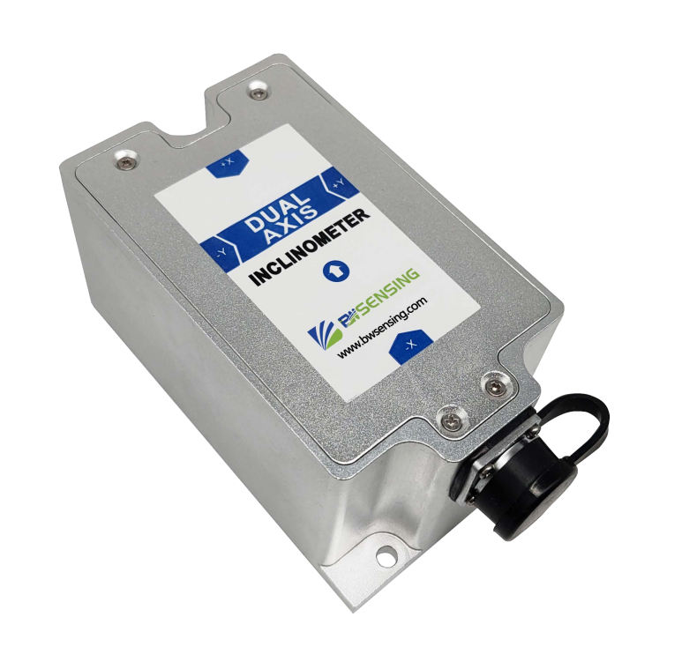
V3.0



BWS5700E Series

High-stability Modbus
Dual Axis Inclinometer
Technical Manual


Introduction
BWS5700E is a dual-axis high-precision, high-stability inclinometer with MEMS technology and digital output, with a surge (impact) immunity of IEC 61000-4-5 level IV launched by BWSENSING, with a measuring range of ± 15°, the highest accuracy is 0.001°, and the temperature drift is ±0.0003°/℃. It is currently the most accurate product in the industry. The sensor uses a high-resolution differential digital-to-analog converter with built- in automatic compensation and filtering algorithms to minimize errors caused by environmental changes. Convert the change of the static gravity field into the change of the inclination angle, and directly output the current roll angle and pitch angle through the digital method. The product is easy to install, simple to use, small in size, resistant to external electromagnetic interference, and strong in vibration and impact. It is an industrial automation, The recommended choice for inclination measurement in surveying and mapping industries!
Feature

- Dual axis tilt measurement
- High accuracy：0.001°
- Cross axis error: 0.001°
- High level EMC Protection
- Temperature drift: 0.0003°/℃
- Wide voltage input 9-36V DC
- Output frequency 5~100Hz adjustable
- OEM customization accepted

Application

  - Bridge deflection monitoring
  - Building health monitoring
  - Precision platform automatic leveling
  - Industrial Equipment automation
  - Tunnel and dam monitoring
  - Tower tilt monitoring
  - Surveying and Mapping Instruments
  - Wind turbine tower monitoring

Product Features


Electrical Index

Voltage (V) | 9-36V DC
Working Current (mA) | 50mA（12V）；40mA（24V）
Operating temperature(℃) | -40~85℃
Storage temperature(℃) | -55~100℃

Performance Index
Measurement Range (°) | Condition |  | ±5 |  |  |  | ±15
Measurement axis | Mutually perpendicular |  | X-Y |  |  |  | X-Y
Accuracy (°) | Room temperature |  | 0.001 |  |  |  | 0.003
Cross axis error (°) | -40~85℃ |  | 0.001 |  |  |  | 0.003
Resolution (°) | Completely still |  | 0.0001
Zero bias (°/℃) | -40~85℃ |  | ±0.0003
Start-up time |  |  | ＜3s
Output frequency (Hz) | 5-100Hz adjustable |  | Up to 100
Baud rate | Adjustable |  | 2400~115200
Mean time between failures MTBF | ≥90000 h/time
Electromagnetic compatibility | According to GBT17626
Insulation resistance | ≥100MΩ
Weight (g) | 320 (metal plug) / 350 (airline plug)
Electrostatic Discharge (ESD) | IEC 61000-4-2 Class IV |  |  |  | Contact discharge 8KV, air discharge 15KV
Fast transient burst immunity | IEC 61000-4-4 Class IV |  |  |  | Repetition frequency 5kHz, positive and negative power supply 4KV, signal line 2KV
Surge (shock) immunity | IEC 61000-4-5 Class IV |  |  |  | Positive and negative power supply, signal lines; common mode 4KV

Resolution：The smallest change in the measured value that the sensor can detect and distinguish within the measurement range.
Accuracy：The root mean square error between the actual angle and the angle measured by the sensor for multiple times (≥16 times).

Mechanical Index

Connector | Metal joint（cable1.5m)
Protection Level | IP67*
Shell material | Magnesium aluminum alloy oxidation
Installation | Three M4 screws
Package product size
*Waterproof to IP67 after gluing

Product Size：L104*W62*H50（mm）

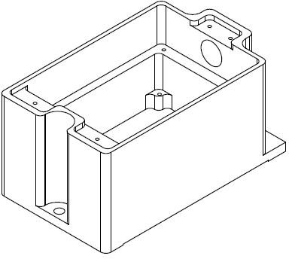
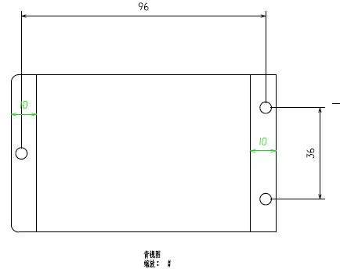

Installation

The correct installation method can avoid measurement errors. When installing the sensor, please do the following:


First of all, make sure that the sensor mounting surface is completely close to the measured surface, and the measured surface should be as level as possible. There should be no included angles as shown in Figure A and Figure C. The correct installation method is shown in Figure B and Figure D.





A
B
uneven surface generates the angle
the measured surface the measured surface



uneven surface generates the angle
the measured surface the measured surface
C
D

Secondly, the bottom line of the sensor and the axis of the measured object cannot have an angle as shown in Figure E, and the bottom line of the sensor should be kept parallel or orthogonal to the axis of rotation of the measured object during installation. This product can be installed horizontally or vertically (vertical installation needs to be customized), and the correct installation method is shown in Figure F.

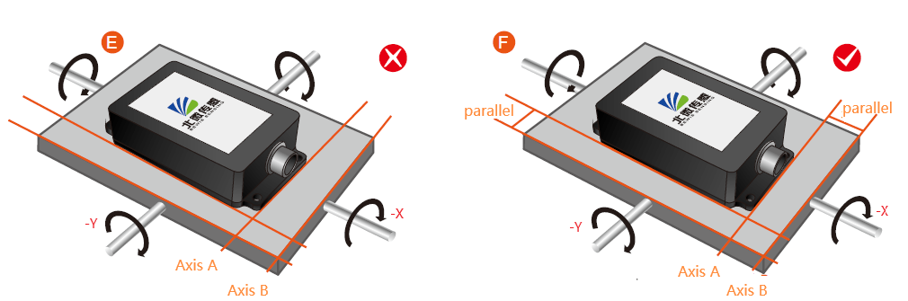
Finally, the mounting surface of the sensor and the surface to be measured must be tightly fixed, smooth in contact, and stable in rotation, and measurement errors due to acceleration and vibration must be avoided.

RED VCC
Electrical Interface

Electrical interfaces
Cable color  & Function | RED |  | BLUE |  | BL ACK |  | GREEN |  | YELLOW
Cable color  & Function | 1 |  | 2 |  | 3 |  | 4 |  | 5
Cable color  & Function | VCC  DC 9-36V |  | NC |  | GND |  | RXD  （B、D-） |  | TXD  （A、D+）

RS 485 wiring diagram
1
5
Inclinometer
4

3

RED VCC
YELLOW D+ GREEN D-
DC9-36V
485+
485- acquisition
Signal
end
BLACK GND
GND
DC9-36V
1
5
Inclinometer
4
YELLOW TXD
GREEN RXD
3
BLACK GND
1 6
2
7
3
4 8
5 9
GND
RS 232 wiring diagram

Debugging Software

You can download the serial debugging assistant directly on the official website (technical service -> download area), or you can use the more convenient and intuitive host computer software.
BWS5700E supporting serial port debugging software can connect the inclination sensor on the computer to display the angle. The software debugging interface is shown in the figure below. Using the tilt angle to debug the host computer, you can conveniently display the current X direction and Y direction tilt angle, and you can also modify and set other parameters.
Step：
① Connect the serial port hardware of the inclinometer correctly, and connect the power supply.
② Select computer serial port and baud rate and click connect serial port.
③ Click start button and the current inclination Angle of the incliner in X and Y directions will be displayed on the screen.

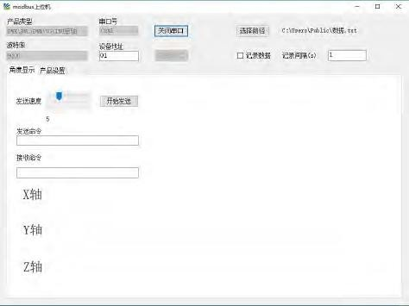

Order information

Product Model |  | Communication mode |  | Package situation
BWS5700E-15-485 |  | RS485 |  | IP67/Metal interface
BWS5700E-15-232 |  | RS232 |  | IP67/Metal interface
BWS5700E-15-TTL |  | TTL |  | IP67/Metal interface
Executive standard

● National Standard (Draft) for Static Calibration of Biaxial Inclination Sensors
● GB/T 191 SJ 20873-2003 General Specification for Tiltmeters and Leveling Devices
● GJB150-3A High temperature test
● GJB150-4A Low temperature test

BWS5700E Series

High-stability Modbus
Dual Axis Inclinometer

Wuxi Bewis Sensing Technology LLC

Add：Building 30, NO. 58, Xiuxi Road, Binhu District, Wuxi City, Jiangsu Province, China
Tel：+89 18921292620
Mail：sales@bwsensing.com Web：www.bwsensing.com

