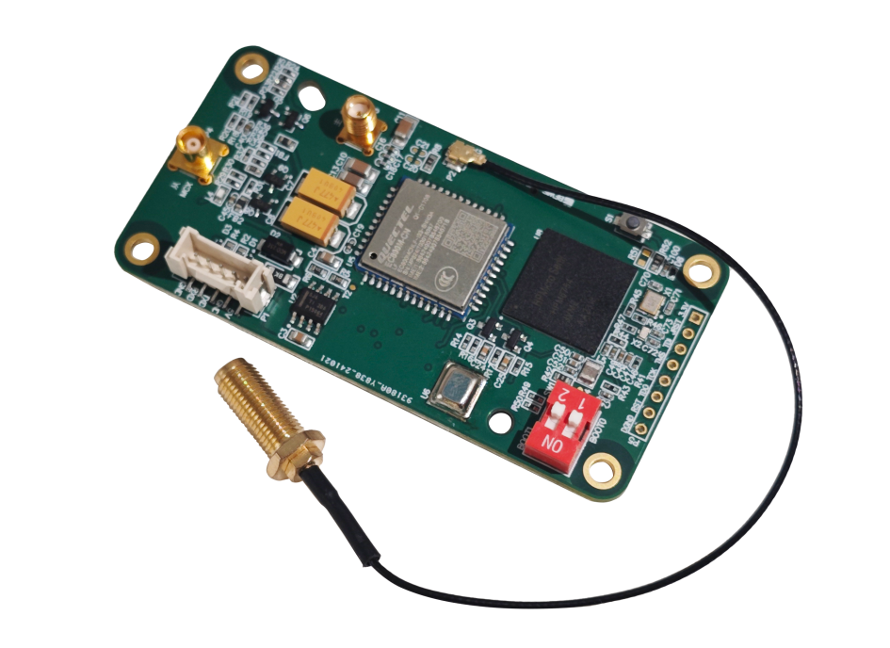

Technical Manuals
Dual Antenna Intelligent Positioning Terminal
BW-GI100 Series
V1.3





BW-GI100 is an intelligent module based on GNSS high-precision positioning technology and IoT communication technology, adopting high-precision MEMS IMU with built-in automatic compensation and filtering algorithm. It adopts unique integrated design with built-in GNSS full-band antenna receiving module, 4G IoT communication module, high-precision GNSS positioning board, high-precision posturing module and OTA online upgrade function. The board adopts excellent anti-electromagnetic interference design, compact and portable, beautiful and generous, can be applied to a variety of complex scenes, can be widely used in directional measurement and other fields.

Introduction

Main Feature

●RTK accuracy: Plane 0.8cm + 1ppm ;
Elevation 1.5cm + 1ppm;
●PPP accuracy：Plane 25cm; Elevation25cm；
●Orientation accuracy (0.6m baseline)：
±0.5°(1σ)，±1°(2σ)
● Satellite tracking
● Petroleum geological exploration
● Optical rangefinders
● GPS-assisted navigation

● Interface support: TTL
● Main board size: L40*W80*H12.6 (mm)
● Power supply voltage: 5V DC
● Operating temperature: -40°C to +70°C

Application

● Cloud Platform Equipment
● Marine surveys
● Underwater navigation
● Mechanical controls

RTK | Plane  Elevation |  | 0.8cm+1ppm  1.5cm+1ppm
ppp | Plane  Elevation  Convergence time |  | 25cm  25cm  15-25min
First positioning time | cold start  warm start |  | <30s  <15s
Maximum data rate | GNSS raw observations  GNSS RTK positioning  GNSS/INS solving  IMU raw data rate  Positioning information output |  | 20HZ  20HZ  200HZ  200HZ  1HZ
Orientation accuracy  0.6m baseline | 1σ  2σ |  | ±0.5°  ±1°
Connector | Motherboard Interface 1x5-bit, 2mm Pitch Pin Connector
4G-RTK antenna interface | I-PEX 20279（MHF）
GNSS main antenna interface | SSMA Female connector
GNSS slave antenna | MCX Female connector
Mounting | Four M3 screws (unthreaded)
Power voltage(V) | 5V DC
Working Current (mA) | 30mA（40mA max）
Operating Temperature (℃) | -40℃~+70℃
Storage Temperature (℃) | -55℃~+100℃



Mechanical Index

Performance Index

Electrical Index

Product Feature


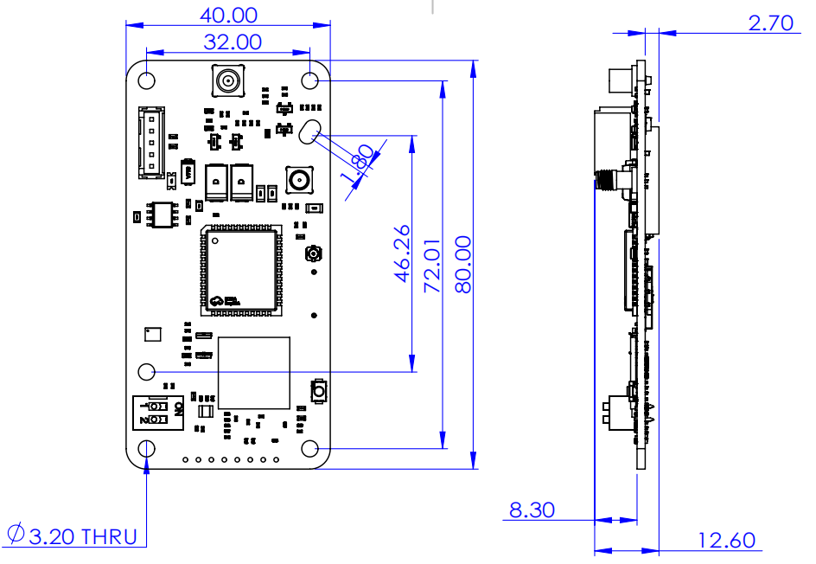
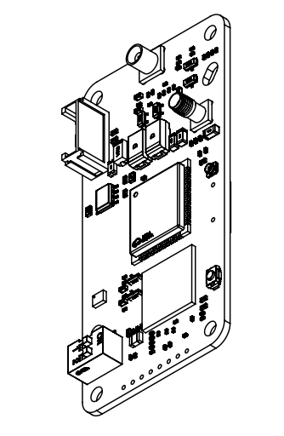
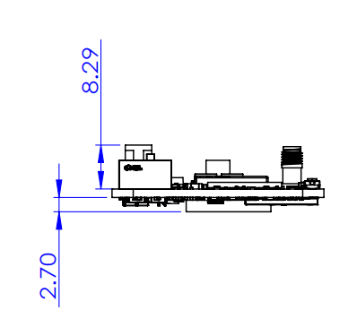
Motherboard Dimensions
Serial |  | Name |  | Quantity
1 |  | GNSS main antenna, SMA Female to SSMA Male Adaptor |  | 1
2 |  | GNSS slave antenna with SMA/MCX-KJ adapter |  | 1
3 |  | 4G antenna and adapter cable |  | 1
4 |  | SIM card |  | 1
5 |  | Signal output cable with pins VCC, GND, TX, RX |  | 1
- Installation of SIM, install the SIM card in the corresponding slot
- Installation of the conversion connector, the bare board is marked with master and slave antenna female connector, according to the interface type in accordance with the completion can be
- To install the antenna, simply connect the antenna to the adapter connector
- Install the 4G antenna and use the 4G antenna connection cable to connect the 4G antenna to the 4G connector on the bare board.

- Setting the baud rate
- CONFIG COM1 115200 Set the baud rate to 115200
- Setting the output frequency（currently supports two output frequencies）
- INSPVAB COM1 0.05 20HZ Output
- INSPVAB COM1 1 1HZ Output
- Stop output
- UNLOG
- Save Settings
- SAVECONFIG After setting the corresponding configuration, you need to save the settings, otherwise revert to the original state after reboot.
- Set Qianxun CORS account
- $CFG,NRTIP,XXXXX,XXXXX* XXXXXis the corresponding account number and password
- $CFG,NRTIP, , * Delete the corresponding account and password
- 4G Card Related Enquiry
- $ZJCX,4G,SIM* Query 4G SIM status
- $ZJCX,4G,NET* Query 4G network status
- $ZJCX,4G,TRAFFIC* Query 4G signal status
- $ZJCX,4G,CSQ* Check 4G signal strength
- $ZJCX,4G,SIM,CCID* Query SIM card number

Instruction Description
Instructions for use
Accessory List
Wuxi Bewis Sensing Technology LLC
Add：Building 30, NO. 58, Xiuxi Road, Binhu District,
Wuxi City, Jiangsu Province, China
Tel：+86 18921292620
Mail：sales@bwsensing.com
Web：www.bwsensing.com

Dual Antenna Intelligent
Positioning Terminal

BW-GI100 Serial

